# Cook to the Root! Sponsorship

* [Home](https://newroots.org/)
* Cook to the Root! Sponsorship

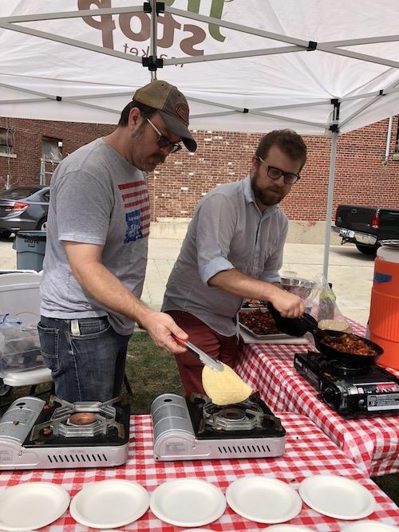

## Your Cook to the Root! sponsorship makes it possible for New Roots and our volunteer chef and culinary enthusiast corps to do cooking demos at every Fresh Stop Market during the 2019 growing season.

|  |
| --- |
| **Amount**  **\*** |
| $1500 - Beet Level Sponsor |
| $1000 - Cucumber Level Sponsor |
| $500 - Carrot Level Sponsor |
| $250 - Okra Level Sponsor |

$

**Donation Schedule**

One Time Monthly Quarterly Annually

Contact Information

**Name**

First Name

Last Name

**Organization/Employer**

**Email**

**Phone**

**Address**

Address Line 1

Address Line 2

City

State/Province

ZIP/Postal Code

|  |
| --- |
| **Amount**  **\*** |
| $1500 - Beet Level Sponsor |
| $1000 - Cucumber Level Sponsor |
| $500 - Carrot Level Sponsor |
| $250 - Okra Level Sponsor |

$

**Donation Schedule**

One Time Monthly Quarterly Annually

Contact Information

**Name**

First Name

Last Name

**Organization/Employer**

**Email**

**Phone**

**Address**

Address Line 1

Address Line 2

City

State/Province

ZIP/Postal Code

Country

**Silent Auction Items**

Donate an item to our silent auction! Describe item and value.

**How would you like to be recognized?**

## Cooking demos and recipe exchanges are the most important and effective ways for our community to share knowledge on cooking fresh food from scratch.

## New Roots welcomes all new and "seasoned" volunteer chefs, culinary enthusiasts, anyone who would like to learn more about volunteering for New Roots AND all donors to the 2019 Cook to the Root! Cocktail Reception. Guests can sign up to volunteer at any Fresh Stop Market for the 2019 season, meet other food justice leaders, have some small bites and our famous beet cocktail.

## Please join us from 5-7 PM on Sunday, April 7th, 2019 at The Majestic, 1510 Lytle Avenue, in Louisville's Portland Neighborhood.

Add 3% to my total amount to help cover the payment processing fees